**Influencer Industry Newsletter**

***Stat/Fact of the Month:***

[35% of B2B marketers are concerned that content has lost its value after its initial use](https://www.prolificnorth.co.uk/news/marketing-services-news/2019/12/research-b2b-marketers-struggle-deliver-integrated-marketing)

[and don’t believe it can be used again](https://www.prolificnorth.co.uk/news/marketing-services-news/2019/12/research-b2b-marketers-struggle-deliver-integrated-marketing)

**Key Takeaways / 20/20 Trends**

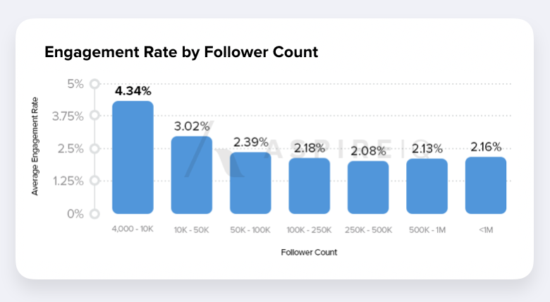 (We are on the right track)

* **Selection**:
  + "Fit over followers"
    - Both in [who](https://www.forbes.com/sites/shanisyphrett/2019/01/31/mission-based-influencer-christina-brown/amp/) is talking (let’s get some more diverse influencers) andwhat we are asking them to say (connect in a naturally fitting way, have some [**cause marketing**](https://www.forbes.com/sites/shanisyphrett/2019/01/31/mission-based-influencer-christina-brown/amp/) backing) [Forbes, [The Drum](https://www.thedrum.com/opinion/2019/12/13/seven-predictions-influencer-marketing-2020)]
  + Diversity
    - *“On a similar note, brands will* [***need to be purposeful***](https://www.adweek.com/brand-marketing/influencer-marketing-has-an-implicit-bias-problem/) *about choosing influencers from diverse populations and backgrounds. The era of the always-Caucasian, always-thin, always-blonde influencer showing off her latte foam art has (thankfully) mostly gone by the wayside. Audiences increasingly want to see content that reflects their own reality.” (*[*link*](https://www.forbes.com/sites/forbesagencycouncil/2019/12/12/five-influencer-marketing-trends-that-will-shape-2020/)*)*
  + Micro most highly engaged, Macro helps to drive scale – answer is a mix of sizes

#### **Metrics**:

* + Standard measurement will move beyond the superficial [[AdAge](https://adage.com/article/opinion/5-ways-influencer-marketing-will-evolve-2020/2224401)]
  + CPE is increasingly being used (avg $0.26 / compared with $1-2 CPC for digital advertising)
* **Content**:
  + Brands are leveraging across channels and platforms
  + Average savings of 24% of in-house creation (current est. is that 60% of cost of influencer goes to reaching their target customers / 40% is spent on content creation);
  + Trend is toward more relatable and not so heavily stylized
* 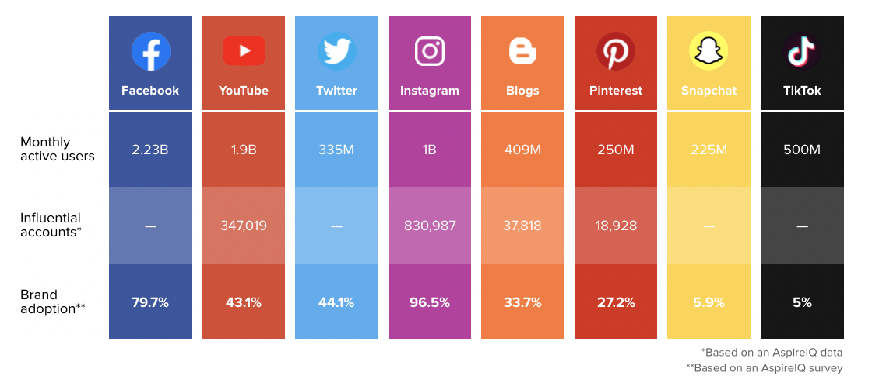**Platforms**:
  + IG still top used platform for Influencers
  + TikTok is on the rise as are Gaming platforms
  + Video is growing
* **Engagements:** 
  + Longer-term, with ability to reuse & repurpose
* **Brand purpose becomes essential:** 
  + Deloitte Research found that 80% of consumers would be willing to pay more for a product if the brand focused on becoming more environmentally and socially responsible / purpose driven narratives; Accenture study of 30K consumer found that 62% of customers want brands to address topical issues - they are looking for a brand that matches their own values. Gen Y & Z are using social media to shop and discover brands (70% learn about products they’re interested in buying on social media)

*Supporting Articles*

|  |  |
| --- | --- |
| [**Forbes Council Post**](https://www.forbes.com/sites/forbesagencycouncil/2019/12/12/five-influencer-marketing-trends-that-will-shape-2020/#2b95bc7731ef) | [**AdAge**](https://adage.com/article/opinion/5-ways-influencer-marketing-will-evolve-2020/2224401) |
| [**Aspire IQ**](https://www.aspireiq.com/blog/10-influencer-marketing-statistics-2020) “Statistics You Need to Know Going into 2020” | [**MailChimp Report**](https://assets.ctfassets.net/yzco4xsimv0y/16qFgLjYFHi6CEaMmB7UEK/0321720973b335e363cb05f94d2cc35e/2019-Mailchimp-Report_Look-Ahead-2020-Trends.pdf) |
| [**The Drum**](https://www.thedrum.com/opinion/2019/12/13/seven-predictions-influencer-marketing-2020) |  |

**Case Study:** [**Christina Brown**](https://www.forbes.com/sites/shanisyphrett/2019/01/31/mission-based-influencer-christina-brown/amp/) *“...some influencers are set on using their influence for good.”*

*(h/t Corey)*

**Other articles of note:**

* [10 stories of turning hobbies into careers (Carla Lylesound from Micro Main Street shows up :] )](https://www.entrepreneur.com/slideshow/343907)
* [Intuit & their like can’t hide free tax offerings](https://www.engadget.com/2019/12/31/free-file-alliance-irs-agreement/) ***
* [SC Ruling: Sales tax even if no physical presence](https://www.forbes.com/sites/kellyphillipserb/2019/10/02/new-sales-tax-rules-take-effective-this-week-in-more-than-a-dozen-states/#79f0397b5cfb)*** Great opportunity for VP to bring this type of information
* [Big Money Weed](https://www.greenentrepreneur.com/article/332980?_ga=2.242820550.534259460.1578321470-2093422746.1577570805) Interesting question to float - how does VP feel about these small businesses?

# [The Fun Theory: Volkswagen Masters the Viral Video](https://mashable.com/2009/10/11/the-fun-theory/) **(see below, this is worth discussing) **

* [2 types of Millenials, ‘Mega-llennials & Me-llenials”](https://www.businessinsider.com/2-types-of-millennials-mega-llennials-and-me-llennials-2020-1)
  + Really interesting concept breaking down this abstract label
  + To note (for our targeting in the future); Within this distinction the [split is on financial lines](https://www.businessinsider.com/millennial-generation-gap-great-recession-financial-crisis-money-habits-2019-3) (🡨 2nd article)

**Discussion topics:**

**Let’s talk channels:**

* Is there [value for us in TikTok trends?](https://www.businessinsider.com/emarketer-marketing-on-tiktok-report-2019-11) Should we look to pilot a small test. Not many companies are playing here is there an opportunity for us to get out front?
* Is there a viable strategy in gaming?
  + “ *“If you’re marketing towards young millennials or Gen Z,* [***a gaming strategy***](https://www.adweek.com/brand-marketing/any-brands-not-marketing-in-the-esports-world-is-already-behind-the-curve/) *isn’t a maybe, it’s a must. I have no doubt that by the end of 2020, it’s going to be common practice among all marketers to intersect with gaming. If a young male demographic is important to a brand, they must be in gaming. Period. There’s no there’s there’s no greater way to target young males than via gaming.”* ” [(link)](https://www.adweek.com/brand-marketing/how-to-reach-gen-z-in-2020-beyond-authenticity/)
* Platforms – what is our social strategy / what channels are we focusing on / what do we think of twitter

**Amplification**

* Industry averages suggest that amplification should be at about 20% of influencer investment. How do test this to be sure we are at the right levels

**Election year.**

* What kind of influencers can we tap into since more people will be tooling around twitter? Do we want to play here?

**[“**Fun Theory**”](https://www.youtube.com/watch?v=SByymar3bds)** (Volkswagen)

* There is something to this, and VP should align on this. We are trying to be more focused on being part of people’s lives and moments. How can we have an activation like this?
* Further on the VW fun stairs story – why did they chose that topic and how does it align with their brand?

**Looking inward**

* What do we think of our diversity so far and what groups are we missing / should we look to better include?