***Stat/Fact of the Month:***Millennials will pay attention to content for [***12 seconds***](https://www.visioncritical.com/blog/gen-z-versus-millennials-infographics?utm_campaign=Marketing%20Blog%20-%20Daily%20Emails&utm_source=hs_email&utm_medium=email&utm_content=82740151), Gen Z only for [***8 seconds***](https://www.visioncritical.com/blog/gen-z-versus-millennials-infographics?utm_campaign=Marketing%20Blog%20-%20Daily%20Emails&utm_source=hs_email&utm_medium=email&utm_content=82740151)***.***

### **Influencer and Social Community Newsletter**

***Bonus:*** *Instagram content has a ‘shelf life’ of 48 hours. Pinterest’s is 3 months (AspireIQ)*

# **Key Takeaways**

**People DON’T just like to complain! You can react to good stuff, too!**

* [Here’s an interesting survey report from SproutSocial about social listening](https://sproutsocial.com/insights/social-media-monitoring/?utm_source=Sailthru&utm_medium=email&utm_campaign=Issue:%202020-02-18%20Social%20Media%20Today%20Newsletter%20%5Bissue:25729%5D&utm_term=Social%20Media%20Today)
  + Compelling case to be made for proactively
    - “Monitoring tells you ‘what,’ listening tells you ‘why’

(Love this analogy below)

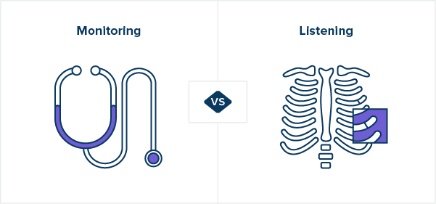

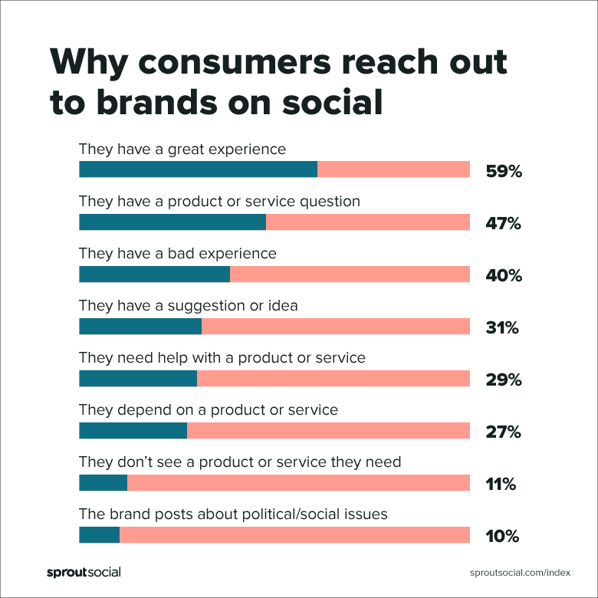

**Your TikTok Minute: It’s evolving…**

* [TikTok introduced a ‘Creator Marketplace’ tool](https://www.businessinsider.com/how-influencer-marketers-use-tiktoks-creator-marketplace-features-2020-1)
  + **Launched in September** allowing marketers to “shop” for relevant influencers (BIPrime). Still in beta, this will be an interesting to continue tracking as strategies for brand on TikTok evolve.
* [Artists are using TikTok to drive sales, find new customers](https://www.businessinsider.com/etsy-artists-making-money-with-sales-from-tiktok-marketing-2020-2)**, particularly on Etsy**
  + **Artists have been seizing the skyrocketing # of users to showcase their work & find new customers: the livestream feature allows to show the process!**

# **Case Studies: A tale of two PR ideas**

[**Oh, Red Sox**:](https://twitter.com/dalekeefeweei/status/1229803491352248323?s=21) a future study of how not to try and use influencers to manage your PR nightmare…

* You will get found out, and called out, sooner rather than later.

**… and the opposite:** A brilliant Bodega owner in Brooklyn has come up with a creative way of building buzz via TikTok & Instagram: [Free Food if you can do some math.](https://www.cnn.com/2020/02/10/us/new-york-deli-five-seconds-free-food-math-trnd/index.html) (CNN)

* Truly, a SMB understanding the power of a good strategy on a relevant platform. And food for thought on using TikTok to connect both your physical and digital communities.

# **Some News of Note**

[Instagram is introducing a tool to clean up your list of people you’re following](https://www.searchenginejournal.com/new-instagram-feature-helps-users-clean-up-their-following-list/347738/?utm_source=daily-carnage&utm_medium=email#close)

* How will this, or will this at all, affect engagement? ([SEJ](https://www.searchenginejournal.com/new-instagram-feature-helps-users-clean-up-their-following-list/347738/?utm_source=daily-carnage&utm_medium=email#close))

[YouTube is testing Viewer Applause which allows viewers to ‘tip’ creators](https://www.tubefilter.com/2020/02/12/youtube-monetization-tool-viewer-applause-tip-creators-twitch-cheer-emojis/) ([Tubefilter](https://www.tubefilter.com/2020/02/12/youtube-monetization-tool-viewer-applause-tip-creators-twitch-cheer-emojis/))

* Another way of engaging and, therefore, another means of measurement.

[How this tiny store idea hasn’t blown up is beyond me](https://www.kfyrtv.com/content/news/Tiogas-tiny-buildings-transition-small-business-owners-567858361.html?fbclid=IwAR1c3H4v0ygK240wkjzAelgZEQRwpqzPNeA_1fhjNi1H5FNvw-jZEYNLRu8) (KFYRTV)

* Seems like an idea waiting for a sponsor

# **Questions for Further Discussion**

An article ([BI Prime](https://www.businessinsider.com/influencer-marketing-metrics-for-tracking-successful-campaign-youtube-instagram-2020-2)) lays out for us again that ‘likes’ and ‘followers’ are becoming less relevant as we think about influencer success. Well-tread ground, but an always relevant question:

**How can a business come up with innovative measurements?**

Yes, you want to compare to industry standards – but what if you could ***set*** industry standards by coming up with a new way of thinking about ‘engagement’ (actions, intent, time spent etc etc)

Is TikTok the new way to help a brand PR – seems like a great place for the social “Challenges” and could easily be tied to a worthy cause. It certainly seems to be an effective tool for a small business to generate goodwill if wielded properly – which company is going to figure out how to harness it in that same way first….?