***Stat/Fact of the Month:***[Pinterest](https://protect-eu.mimecast.com/s/ed_yCNZXt0Zzllotm8z9hs) passed Snapchat as the third-biggest social media platform in the U.S. in 2019, *(per* [*eMarketer*](https://protect-eu.mimecast.com/s/ed_yCNZXt0Zzllotm8z9hs)*)* **Key Takeaways**

1. [**Social Commerce**](https://etaileast.wbresearch.com/): your social channels should now be part of your ecommerce strategy.

* Social media + ecommerce = new online shopping dynamics.
* Social platforms now a place where people can buy & are sometimes expected to be places for:
  + Entertainment
  + News
  + Product research,
  + Community building [(eTail research)](https://etaileast.wbresearch.com/)

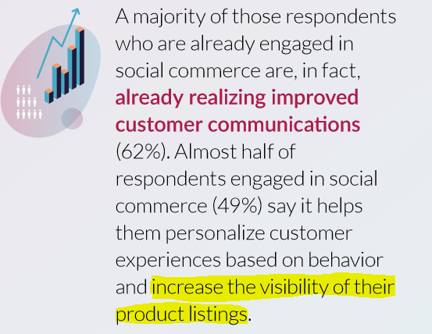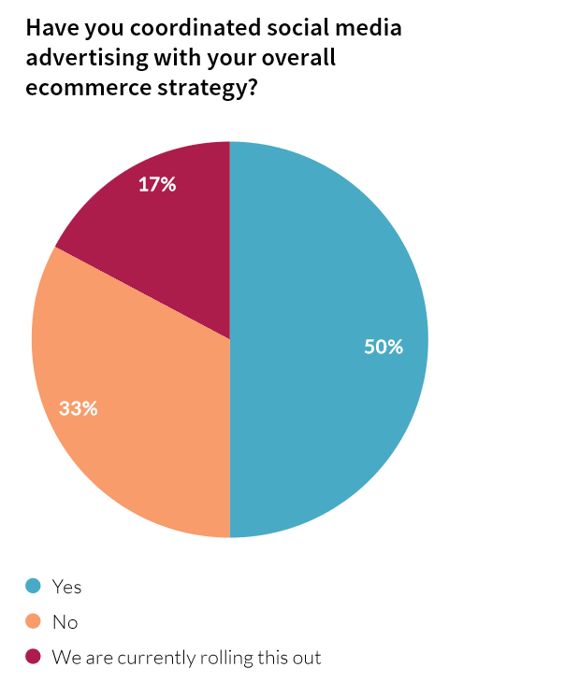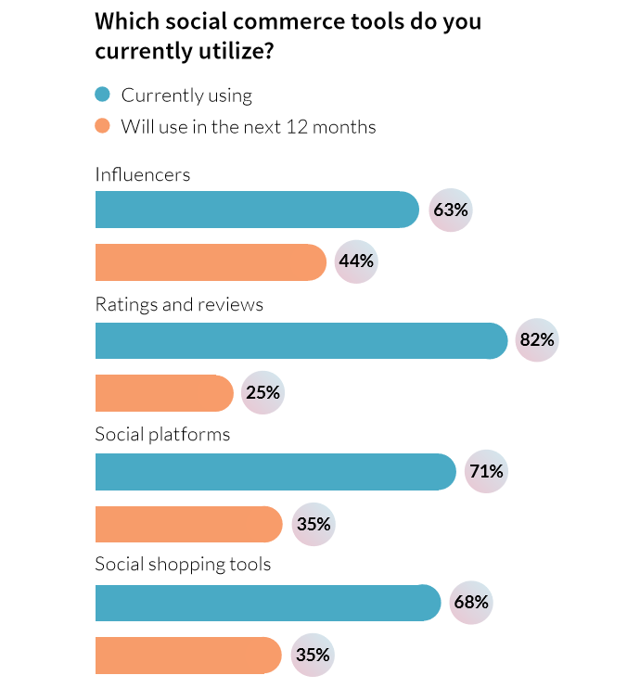

1. **USE YOUR CUSTOMERS TO PRODUCE CONTENT, IF NOT FULL-BLOWN ADS!**

* [Examples of large companies using TikTok](https://blog.hubspot.com/marketing/tiktok-sponsorships?utm_campaign=Marketing%20Blog%20-%20Daily%20Emails&utm_source=hs_email&utm_medium=email&utm_content=81761645). Numbers 4 & 5 should be of particular note
* Allow influencers to be more than just paid content - [let them be an advertiser](https://digiday.com/marketing/influencer-advisory-board-clorox-changing-youtube-advertising-strategy/) ([Digiday](https://digiday.com/marketing/influencer-advisory-board-clorox-changing-youtube-advertising-strategy/))
  + This means a level of trust. Trust that with the proper direction, these folks are creative enough to come up with interesting content relevant to *their* audience. [Taking the time to pick the right people](https://cdn2.hubspot.net/hubfs/4030790/MARKETING/Resources/Education/E-Books/Influencer%20Marketing%20Benchmarks%20Report%202019/InfluencerDB_Influencer-Marketing-Benchmarks-Report-2019.pdf) is an essential step early in the process. ([HubSpot / InfluencerDB study](https://cdn2.hubspot.net/hubfs/4030790/MARKETING/Resources/Education/E-Books/Influencer%20Marketing%20Benchmarks%20Report%202019/InfluencerDB_Influencer-Marketing-Benchmarks-Report-2019.pdf))

1. **Please, take a stand.**

**Case Studies:**

**Not Who you’d expect… but they’re reaching the right people.**

* [Oh I Wish I Were an Oscar Myer Weiner](https://www.marketingdive.com/news/oscar-mayer-seeks-hotdogger-brand-ambassadors-for-national-wienermobile-t/569915/)
  + Oscar Meyer has been ahead of the brand ambassador curve -they’ve been looking for “hotdoggers” since 1988!
    - One-year full-time paid brand ambassador position
* [The New York Jets are very bad… but maybe are really good at reaching out to new fans?](https://www.si.com/johnwallstreet/sports-business/jets-influencer-program)
  + NY Jets have been using an influencer program to seek out non-traditional fans
  + It’s a way of reaching tangential ‘fans’ (food, entertainers, gamers)- by having them sample & showcase the gameday experience

**Other articles of note:**

# [Goodbye, Marlboro Man: How marketers are breaking with traditional notions of masculinit](https://www.marketingdive.com/news/goodbye-marlboro-man-how-marketers-are-breaking-with-traditional-notions/530094/)y

* + This is older but something I want to bring up in relation to influencers - who they are, in the whole spectrum of people customers respect & connect with in their online communities.
  + “Non-Traditional” influencers (read: not pretty and blonde with a shiny life) is an avenue for new ways to hit on outside-your-normal customers and widen a company’s view.
  + This relates to the article below and just what ‘taking a stand’ actually means.
* [Taking a stand does not mean taking a side](https://www.forbes.com/sites/forbesagencycouncil/2019/07/01/taking-a-stand-how-brands-are-tackling-social-issues/#3a1c599e2e59)
  + Sallie Burnett, a loyalty consultant discusses some successful Brands tackling social issues
  + Within the article she inadvertently makes an excellent point - ‘taking a stand’ does not mean tipping the political/social scales (which we are often uncomfortable doing). We could stand up and tackle financial literacy, access to loans, race/gender inequality in funding of small businesses, rural entrepreneurs etc…
    - Certainly helpful with a younger audience, but research shows everyone wants it:
      * [Forrester](https://www.forbes.com/sites/forrester/2018/05/23/millennials-call-for-values-driven-companies-but-theyre-not-the-only-ones-interested/#38aea1b75464)
    - [SproutSocial](https://www.marketingdive.com/news/nearly-70-of-consumers-feel-brands-should-get-more-political-study-finds/514428/) (more snippets & key facts at the end)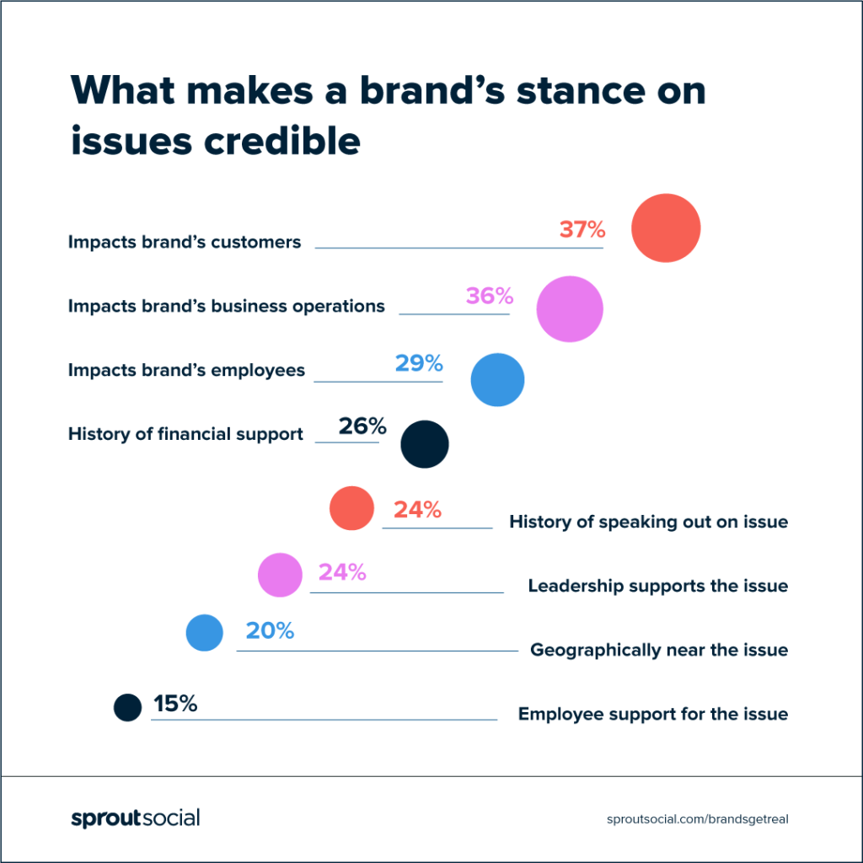

**Discussion topics:**

[**“Millenials,”**](https://www.goldmansachs.com/insights/archive/millennials/) a helpful guide.

[**“Zoomers,”**](https://storage.googleapis.com/zebraiq/Zebra%20IQ%202019%20The%20State%20of%20Gen%20Z.pdf) a helpful guide

* [**Influencer Studio Space**](https://www.businessinsider.com/village-studio-instagram-influencer-studio-brooklyn-la-photo-tour-2020-1): How can we tweak this idea?
  + Could this be something we host? Sponsor?
  + Not just for ‘influencers’ but a ‘brand consultant’ studio experience
  + Could be stand-alone or pop-up in cities based on saturation

**Here’s a handy list from AspireIQ. Call it “*TL;DR - Brand Ambassador-ing*”**

1. Encourage conversations that can take place without you
2. Connect your community in real life
3. Listen to your fan base
4. Turn your users into your creators
5. Reward users with loyalty or referral programs
6. Get people to talk about your brand on social
7. Ask everyone to leave reviews
8. Create long-term relationships with ambassadors

**Appendix on SproutSocial research**

* Two-thirds of surveyed consumers believe it's important for brands to take public stances on topics such as immigration, civil rights and race relations, according to findings from [a Sprout Social report](https://www.marketingdive.com/news/nearly-70-of-consumers-feel-brands-should-get-more-political-study-finds/514428/) released in January.
  + I get that companies [want to be careful around this and understand the risks](https://www.adweek.com/agencies/people-apparently-dont-want-brands-to-take-a-stance-on-political-issues-study-says/), but we ought to think more broadly about what taking a public stance can mean.
  + It could simply be supporting something relevant to our customers.
  + Ideally business AND consumer...
* Fifty-eight percent of respondents believe brands should share their opinions on social media — a channel consumers are particularly receptive to, with 61% reporting it's important for brands to post their stances there, specifically.
* Despite obvious political trend lines, 66% of respondents said brands rarely or never influence their opinions on social and political issues. Instead, respondents desire to see brands donate to social causes (39%) and encourage their followers to take similar actions like donating or attending an event (37%).
* Something like **FINANCIAL LITERACY** would be a perfect place to ‘take a stand’ - it fits our customers and ideals, could genuinely benefit the communities we touch, could do it for all ages.
  + If we are interested in our brand’s story… why not start it at the very start, even before someone has a fully-formed dream?
* We should hammer this, and the fact that social is the way to do it speaks to the thing ithe importance of our ‘community’ activity, that is we need a community manager for social, forums and more being PROACTIVE giving us a voice beyond customer service complaints.